Nepal College of Information Technology
Unit Test
Spring 2011
Program : BE CE/ELX Time : 2 hrs
Semester : (II) FM : 70
Subject : Applied Mechanics PM : 35

- Candidates are requested to give their answer as far as practicable in their own words.
- The figure in the margin indicates the full marks
- Attempt ALL question

1. a) Distinguish between centroid and centre of gravity. Calculate the centroid of the parabolic spandrel with length ‘a’ and height ‘h’ as given in fig: 1. (3+7)
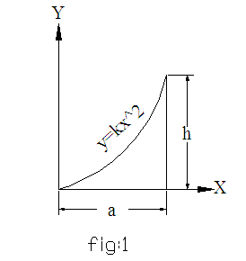

b) State perpendicular axis theorem. Determine the moment of inertia and the radius of gyration of the area enclosed by two curves as shown in fig. (2+8)
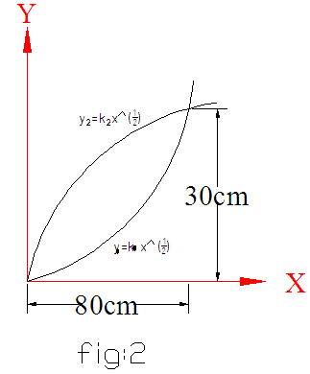

OR

State parallel axis theorem. Determine the moment of inertia and the radius of gyration of the area shown in fig: 3. (2+8)
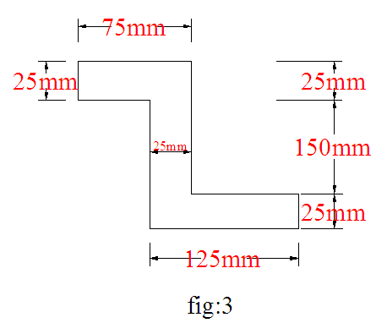

2. a) A block is supported by a system of a cable as shown in fig: 4. the weight of the block is 500N. Determine the tension in each cable DA, DB, and DC. (10)
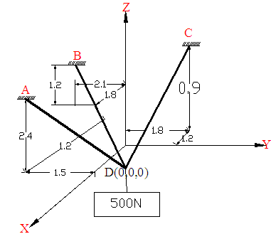
b) A homogeneous metal cylinder weighing 600N is supported by a flexible cable and a smooth inclined plane as shown in fig: 5. Determine the tension in the cable and force exerted by the inclined plane on the cylinder. (10)

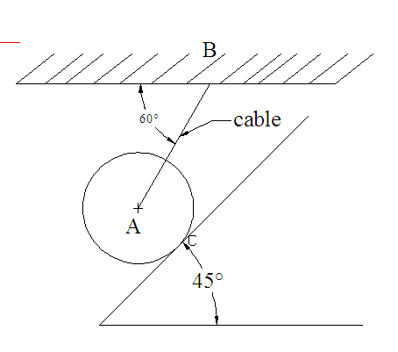`
3) a) A block of weight w₁=1000N rest on a horizontal surface and supports on top of it another block of weight w₂=250N as shown in fig .the block w₂ is attached to a vertical wall by the inclined string AB. Find the magnitude of the horizontal force P, applied to the lower block as shown that will be necessary to cause slipping to impend, the coefficient of friction for all contact surface is 0.3. (10)
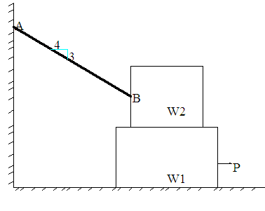
b) What is Angle of Friction? Enlist with sketch the condition illustrating No friction, No Motion, Impending motion and motion. (10)
4) Write short notes (any two). (5x2=10)
a) Resolution of force into a force and couple.
b) Free Body Diagram and guidelines for drawing a good FBD.
c) Moment of force about an axis.
d) Applied mechanics and its scope.

